**Rocket Man Game Design**

**Player Experience:**

* Precision
* Skillful

**Core Mechanic:**

* Skillfully fly spaceship
* Avoid environmental hazards

**Core game loop:**

* Get from A to B to complete the level
* Progress to the next level

**Game Flow and Screens**

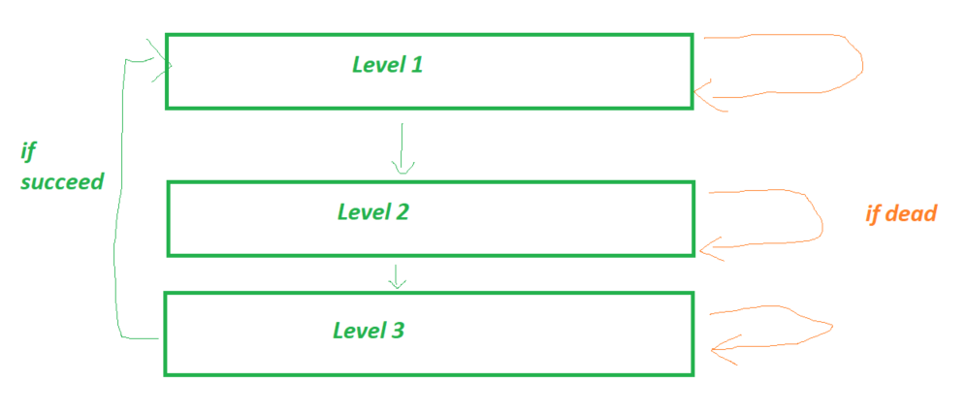

**Game Theme (ie. Story & Visuals:**

* Spaceman with Jumperpack
* Unknown planet, trying to escape

**Onion design:**

Most important feature: movement/flying

2nd most important feature: world collision/die

3rd most important feature: Level progression

All features need to feed the core and make it better

**Create moments for levels**

*Start with moment and than expand the environment around it*

e.g.

Fly under

Fly over

Fly through a gap

Time your flight through moving obstacle

Land on moving platform

Fly through narrow tunnel

*Or tuning moments*

e.g.

Slower rocket (got damaged)

Faster rocket (got a boost)

Darker level

Closer camera

Bigger rockt (carrying something

Reversed controls